Parent Survey Responses
Conducted Parents’ Evening Week 7th-11th November 2022
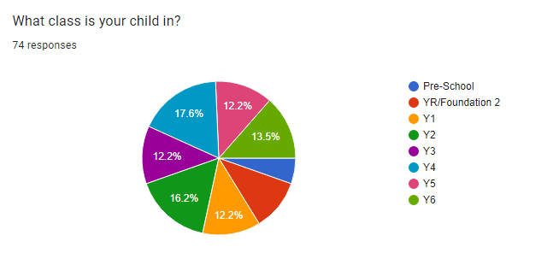
The parent survey was created using Google Forms and was undertaken anonymously online. The results are as follows:

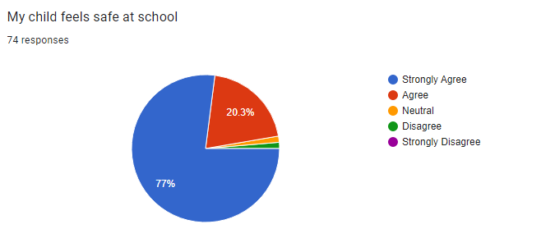
97.3% of parents felt that their children felt safe at school (of which 77% strongly agreed). 1.4% gave a neutral response and 1.4% disagreed.
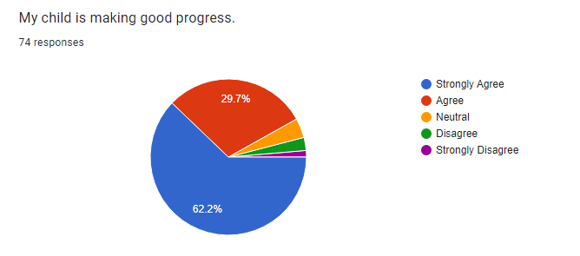

92% of parents felt that their child is making good progress.

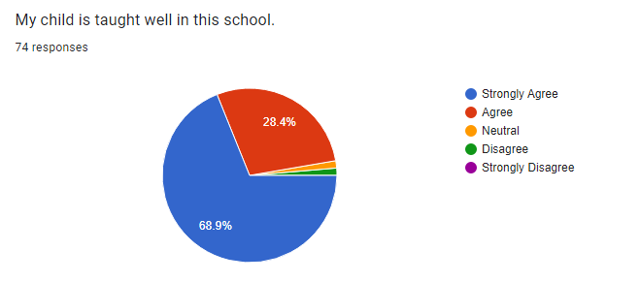
97.3% of parents feel that their child is taught well in this school. 1.4% gave a neutral response and 1.4% disagreed.
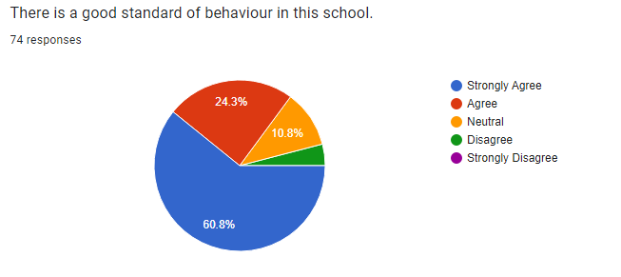

85.1% of parents feel that there is a good standard of behaviour in the school. 10.8% gave a neutral response and 4.1% disagreed.

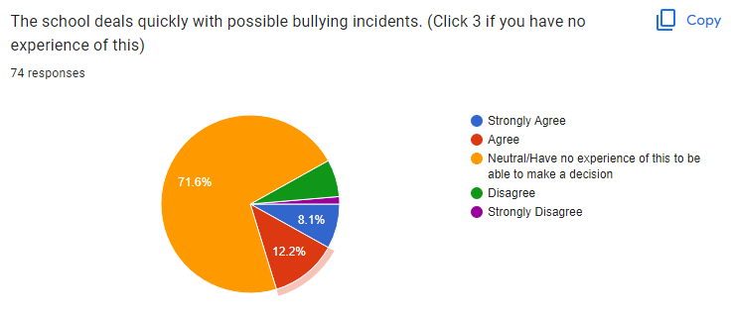
71.6% of parents had no experience of this and could only give a neutral response. 20.3% of parents agreed and 8.2% disagreed.
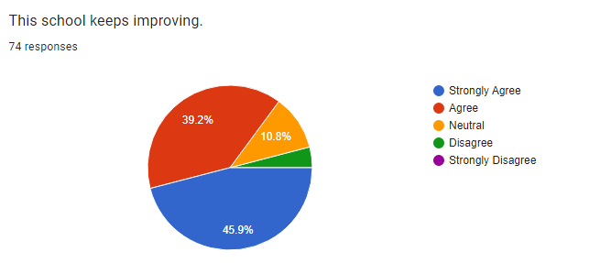
85.1% of parents feel that the school keeps improving. 10.8% gave a neutral response and 4.1% disagreed.
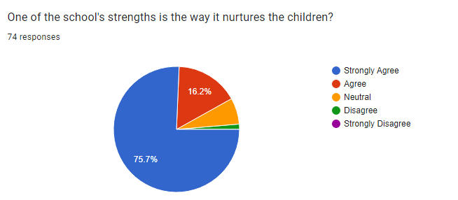
91.9% of parents feel that one of the school’s strengths is the way it nurtures children. 6.8% of parents gave a neutral response and 2.7% disagreed.

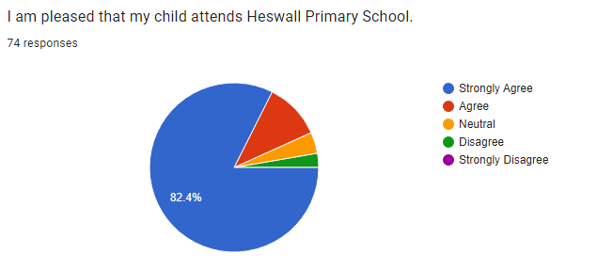
93.2% of parents feel pleased that their child attends the school. 4.1% gave a neutral response and 2.7% disagreed.
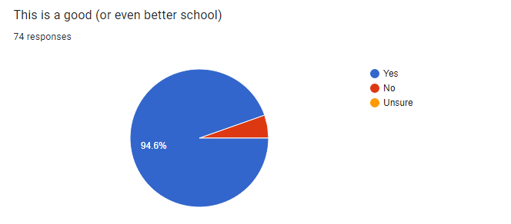
94.6% of parents feel that this is a good (or even better school). 5.4% disagreed.

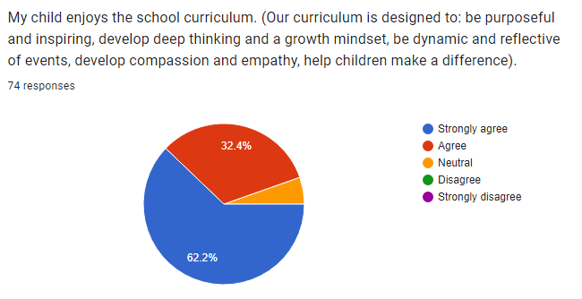
94.6% of parents stated that their child enjoys the curriculum. 5.4% of parents gave a neutral response.
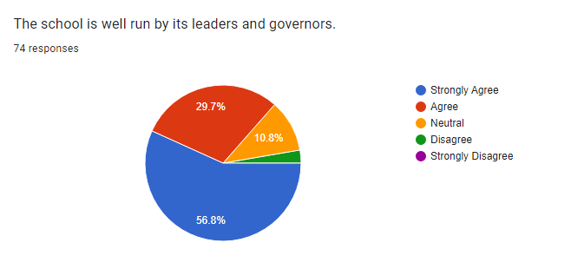
86.5% feel the school is well run. 10.8% gave a neutral response and 2.7% disagreed.

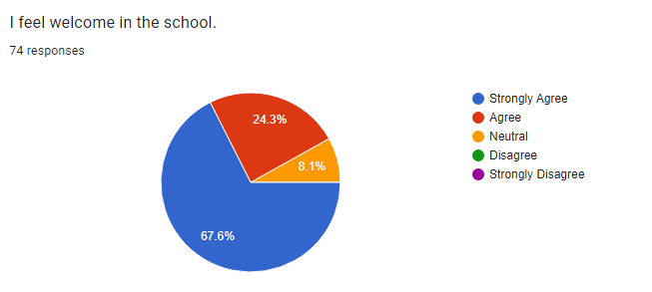
91.9% of parents feel welcome in the school. 8.1% of parents gave a neutral response.

The best thing about the school is
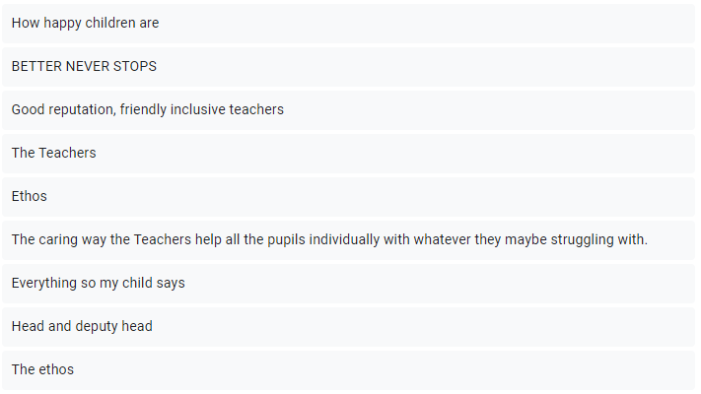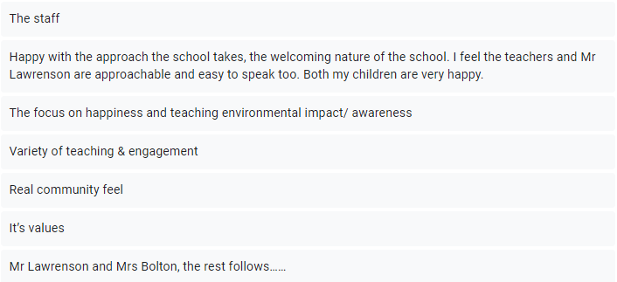

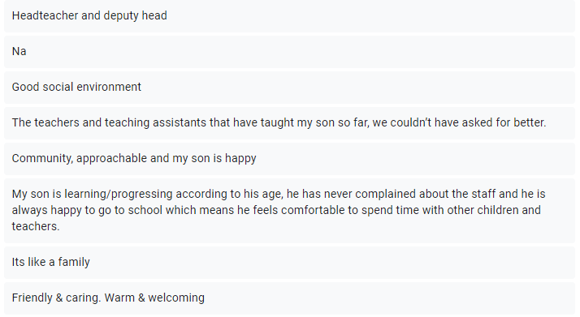
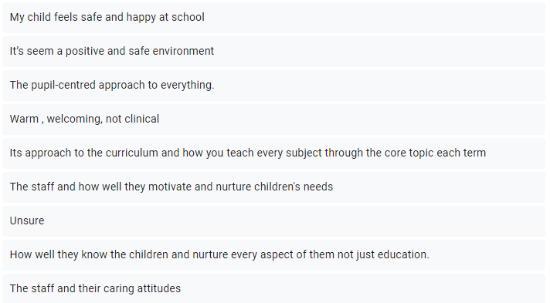

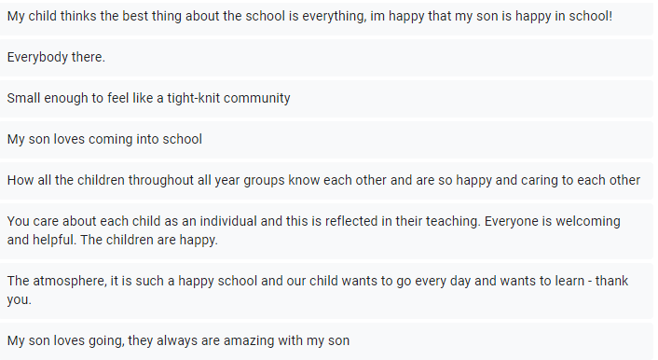
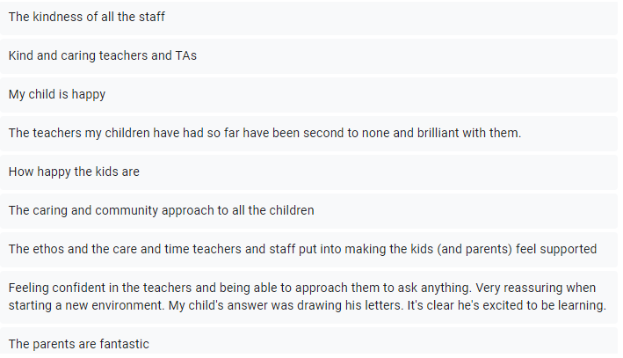
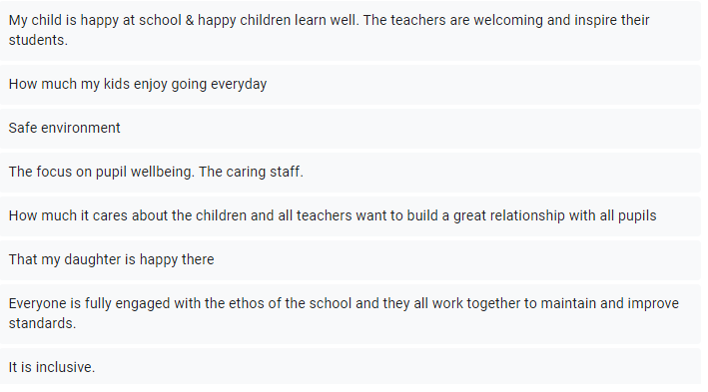

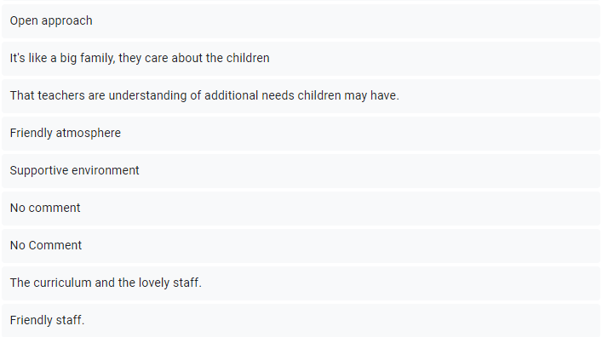
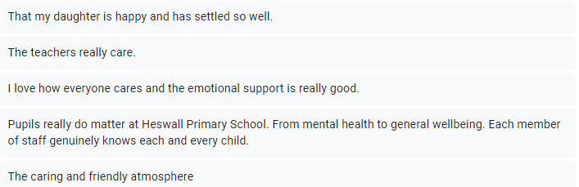

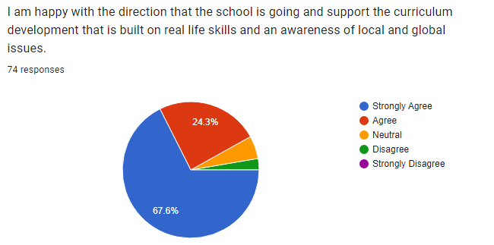

91.9% of parents are happy with the direction of the school and support the curriculum. 5.4% of parents gave a neutral response and 2.7% of parents disagreed.

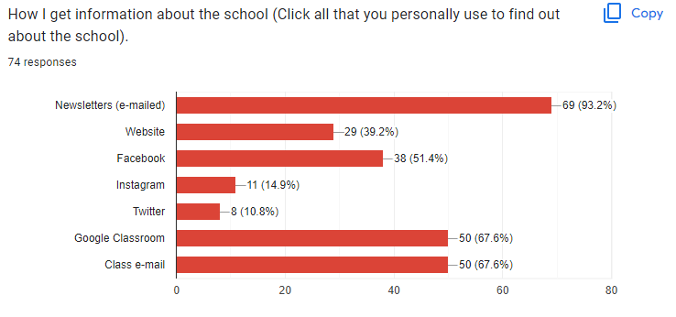
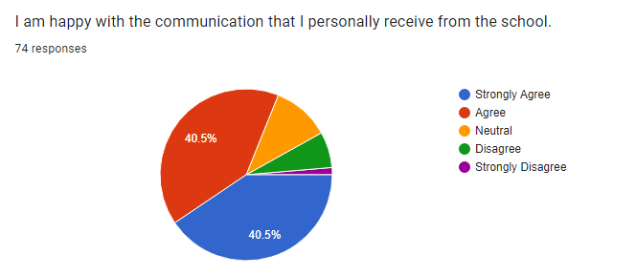
81% of parents were happy with the communication. 10.8% of parents gave a neutral response and 8.2% disagreed.

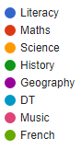
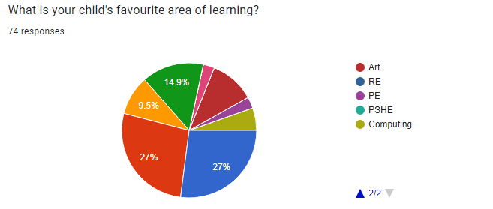
1st –Maths and Literacy 27% each. 2nd-History 14.9%, 3rd- Science 9.5%, 4th Art-10.8%, 5th- Computing 5.4%, 6th - Music and P.E. 2.7% each.

Is there anything else that you would like us to know so we can keep improving the school?
(Comments with children’s identifiable information have not been included in this section although the learning input from the comment will be).

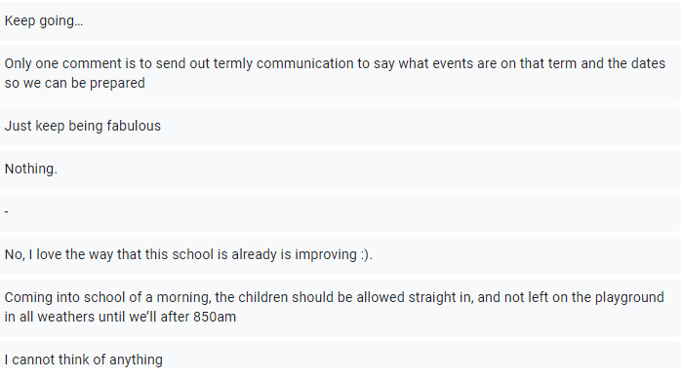
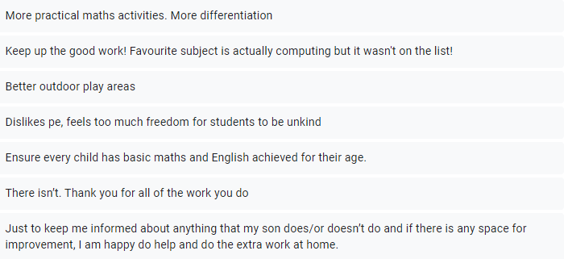
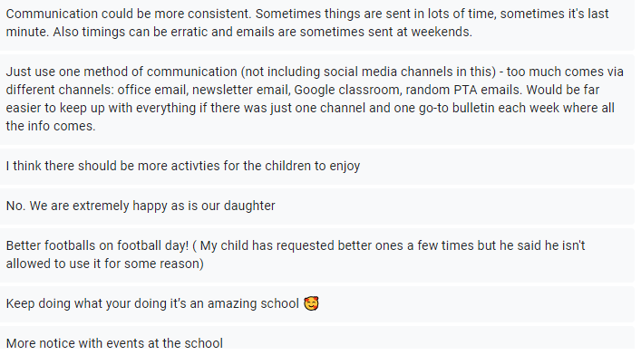
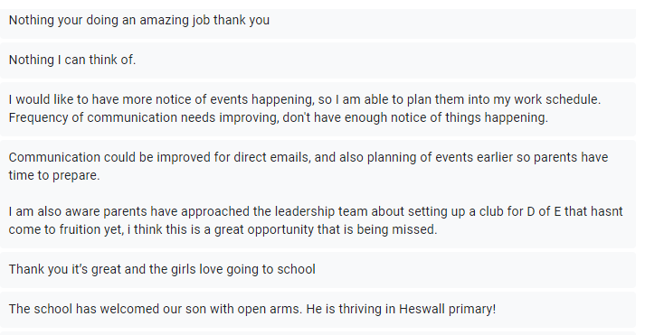
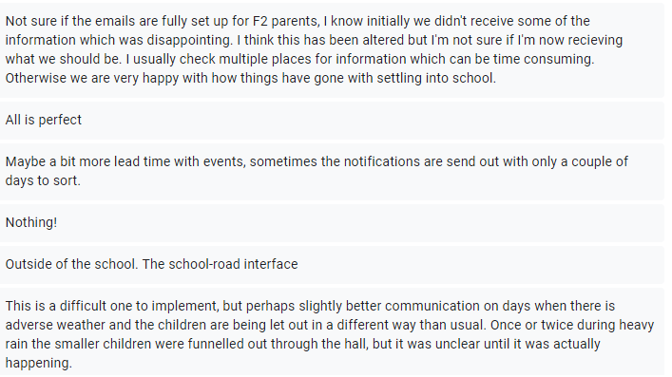

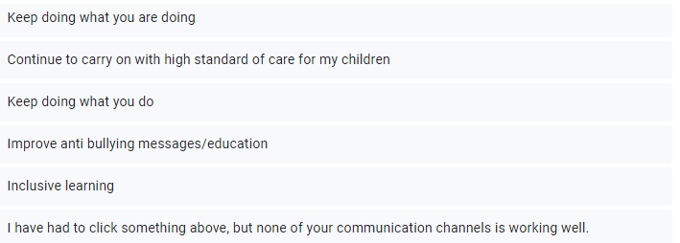
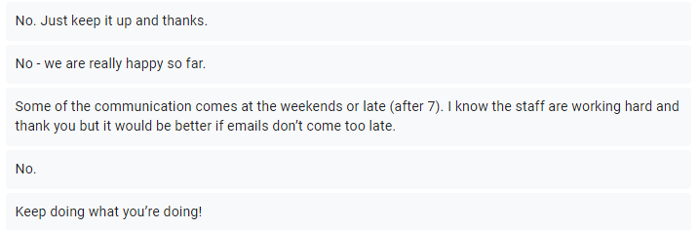

Other comments
- More Y6 children to pass the 11+ and that the 11+ is a good benchmark.

Wirral Primary Schools do not and cannot have any involvement in the 11+. We do not prepare children for the 11+, we do not give the children familiarisation with the tests and as such the success of primary schools must not and cannot be measured on it.
Our academic measures of success are based on the National Curriculum that is at the heart of the children’s learning. Regardless of whether or not they sit the 11+, primary schools’ performances can be measured on assessment points that produce external data e.g. Foundation Stage data, Y1 Phonics Checking, KS1 & KS2 test results (SATs). The children’s attainment and progress information can then be measured. We are also accountable to Ofsted who grade the schools on performance.
Every year, different numbers of children within our Y6 classes sit the 11+ tests at the local grammar schools. Each Y6 cohort varies – sometimes significantly, with different numbers of children with special educational needs and English as an additional language etc. It is impossible to compare each class. Many of the children have private tutors outside of school and this can vary particularly in different areas across the peninsular.
-Communication is not working well/ Inconsistent times/ too many messages in one day.
We take on board many of the comments that people have made. We do have a few different systems and staff will discuss how we can further improve our communication. The communication can be different depending on who it is coming from e.g. the main office will phone you directly or email you using the school office email. When we have to contact large groups of people, we use the eSchools system – this connects to our school data base and therefore it is kept up to date. Teachers will normally contact parents as an individual directly through the class email address that every class has.

Class emails- we provide direct access to the class teachers through a dedicated class email. You can email any concerns to the class e-mail and the teacher will usually pick that up during the school day.
Google Classroom- this is an effective platform that lets you see information, news and tasks specifically for your child’s class.
Newsletters – these are emailed to all parents. These are general information newsletters to keep our parents informed about whole school issues. We do not write these each week.
Social Media – this is our way of communicating with you so that we can share with you, some of the lovely things that happen in school.
School Website – this is packed with day to day and essential information about the school. You can find many of the longer pieces of information here such as the curriculum.

We appreciate that some information has been sent over weekends but we will try our best to ensure that information is sent during the working day whenever possible.

More lead time for events, sometimes the notifications are sent out with only a couple of days before the event.
We will be asking all staff to provide ample time for notification of all future events to avoid stress on families. The school office will continue to add all events on the school calendar. This can be found on the school website.

Can the children come in early when it is raining?
We do not want children getting wet outside and we will allow them to come inside early if it is raining, providing that the teacher is in the classroom to supervise the children. We would advise that the children do not arrive too early e.g. no more than 10 minutes before the start of school.
Improve anti-bullying education
We will never stop reinforcing this message. Anti-bullying messages are given continuously. The school will always deal with any bullying allegations as soon as they are raised and will work with parents. We also have a strong PSHE programme (Jigsaw) and we use assemblies and class discussions to challenge all types of bullying and to spread awareness of different issues to prevent situations occurring in the first place. We also have services within school e.g. ELSA to help our children if they are struggling socially and emotionally.

