21 April 2017
Dear Parents

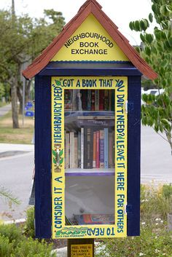
Book Exchange – Can you Help?

You may have noticed that we have been having a big tidy-up in the library. Over the next few months, we will be holding various events to promote reading in school. Esme, Lily, Maddison, Mia and Jaya in Year 4 held a cake sale just before Easter to raise money to buy a book exchange box to put outside the library. After searching the Internet, we cannot find a company who manufactures one.

Can you help? We have funding to buy wood and materials to make a box, but we need a handy mum, dad, granny or grandad to design and make a box. Please let Mrs Bolton know if you could help. We feel this would be a very valuable resource for the school.

500 Words/National Writers Competition

Congratulations to Jack Lane in Year 5 whose BBC 500 word story, “Lost in a Story”, has been shortlisted to a group of 5,000 children from the 131,798 who entered – a wonderful achievement. If your child is interested in entering another exciting competition, why not try the Explore Learning, 500 Word National Writers Competition. The closing date is Friday 5 May. Find more details at explorelearning.co.uk/youngwriters

Bluetit Update

Our blue tits, Betty and Bernard, have been very busy nesting this week. We have at least nine eggs in the nest. Poor Betty is looking quite exhausted already and is looking forward to a good rest, incubating the eggs over the next few weeks. If you would like to see some video clips and photos of the birds in action, look on the gallery section of our school website- there is a file called ‘School Bird Box’.

School Photographs

The School Photographer will be in school on Monday morning to take class photographs. Hair brushed, smiles polished and full school uniform is the order of the day!!

Yours sincerely

J Lawrenson
Headteacher

