Pupil Premium Grant Expenditure Plan Reviewed – September 2018
Heswall Primary School: 2017/2018

Number of pupils and pupil premium grant (PPG) received
Total number of pupils on roll | 218
Total number of pupils eligible for PPG  Based on January 2017 Census.  ‘39 Eligible Deprivation- 17.9% of school’ | FSM Including Ever 6- 25  LAC/Post LAC- 3  Services- 3
Amount of PPG received per pupil | FSM-£1,320  LAC-£1,900  Ever 6 FSM- £1,320  Adopted-£1,900  Services-£300
Total Amount of PPG received (Includes ‘Ever 6 FSM’) | £51,480

Dear Parents,
When reading the statistics of impact of the previous year’s pupil premium allocation, it is very important to know that the percentage of the children is based on the number of Pupil Premium children and not the full class. This data may be compared to the full class non-pupil premium children as well as local and national data. In some cases 100% of pupil premium children will equate to just 1 child if there is only one pupil premium child in the class.

1. Additional Support from teaching assistants in the classroom to facilitate small group teaching and to focus on identified children in various year groups. £14,500.

Whilst class sizes remained healthy, TA support was in every class providing a good pupil to adult ratio. The numbers change per class depending on class need.
YR- 14:1, Y1- 15:1, Y2- 6:1 , Y3 - 10:1, Y4 – 17:1, Y5 - 16:1, Y6 - 17.5:2
2. Specific Intervention (RWI) to focus on Key Stage 1 Phonics. £4480

Impact: 83% of disadvantaged children achieved the Y1 Phonics check score. This is a rise of 43% on the previous year. The average mark for Y1 disadvantaged children in the test was 33. This is a rise of 12 marks more than the previous year.

3. ‘Focus Room’ Children to access social and emotional support via Learning Mentor
£7600
Impact: 13 children accessed the Focus room and 39 separate incidents were dealt with. Some ran continuously throughout the year.

4. Provide targeted Literacy and Numeracy support for a small group of Y6 children using a higher learning teaching assistant. £13,000
Impact: 20% of the 5 Pupil premium Children achieved the expected standard in all areas. For individual subjects: Reading 20% of the 5, Writing 60% of the 5, Maths 80% of the 5.
This data can be compared with the data from all children as shown below. It has been clear that careful use of Pupil Premium money has enabled the overall attainment of the whole cohort to achieve greater than both the local and national averages.
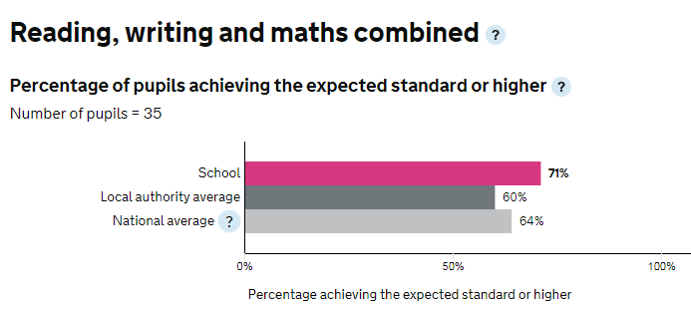

5. Support eligible families to access after school clubs. £2000
Impact - All children were able to access after before, after school and during lunchtime clubs. Some clubs such as Art, Lego, Music, Zen Den, Yoga were made free to children to avoid any cost at all. Pupil Premium health checks were able to pinpoint those children who were not attending clubs and offer places. Zen was particularly useful in ensuring that children were ready for learning each day.

6. Support eligible families by reducing the overall costs of residential visits by 50% - by agreement with the school. £2000
No child missed the residentials to Oaklands and Barnstondale for reasons involving finance. The school uses guidance from the ‘Charging for school activities’ document from the DfE.

7. Support eligible families by reducing the overall costs of school clubs and instrumental tuition-by agreement with the school. £500
Children in Y4 had one full year of recorder lessons from a peripatetic music teacher. All children, including 7/7 children identified as Pupil Premium were provided with their own recorder to keep. Y2 had Ocarina lessons and Y3, Y5 and Y6 worked with The Voice Project. A Key Stage One after school club was run using percussion instruments.
8. Support eligible families by contributing towards the cost of school uniform and PE kit. £500
The school purchased and supplied a number of families with school uniform and PE kit. Other items including school shoes, pumps and trainers were provided.
9. Provide an online reading scheme- Bug Club. £900
All children were given access to Bug Club. All Pupil Premium children were targeted to ensure they had access including using in school when necessary. This provided all children with access to high quality texts with appropriate vocabulary.
10. Provide CPD for staff to ensure that Pupil Premium families are effectively supported e.g. Social and emotional support, Attachment Training, Dyslexia training, Specific medical training including administration of medication. £3000
Staff received appropriate CPD including Talk for Writing, Senco support, SLA to provide more ongoing training including working memory and effective use of teaching assistants (Now completed September 18.
11. Extra Data audits for Pupil Premium Group e.g. data progress, attendance, observations, book scrutinies, analysis of health checks including supply. £3000
Continous monitoring of all children ensured that staff could identify pupil premium children and monitor and plan for them effectively. A staff governor was trained in how to effectively analyse in school data in order to help identify gaps. Data was provided to governors and Pupil Premium Health Check sheets were completed.

