Y1 : Autumn 1& 2: Medium Term Plan
Overall outcome
​Circle time – can the children share one similarity and one difference with a child from our key text.
​
Curriculum areas that will be covered in stand-alone units during this topic:
Science
Maths
RE
PE
Phonics
ICT
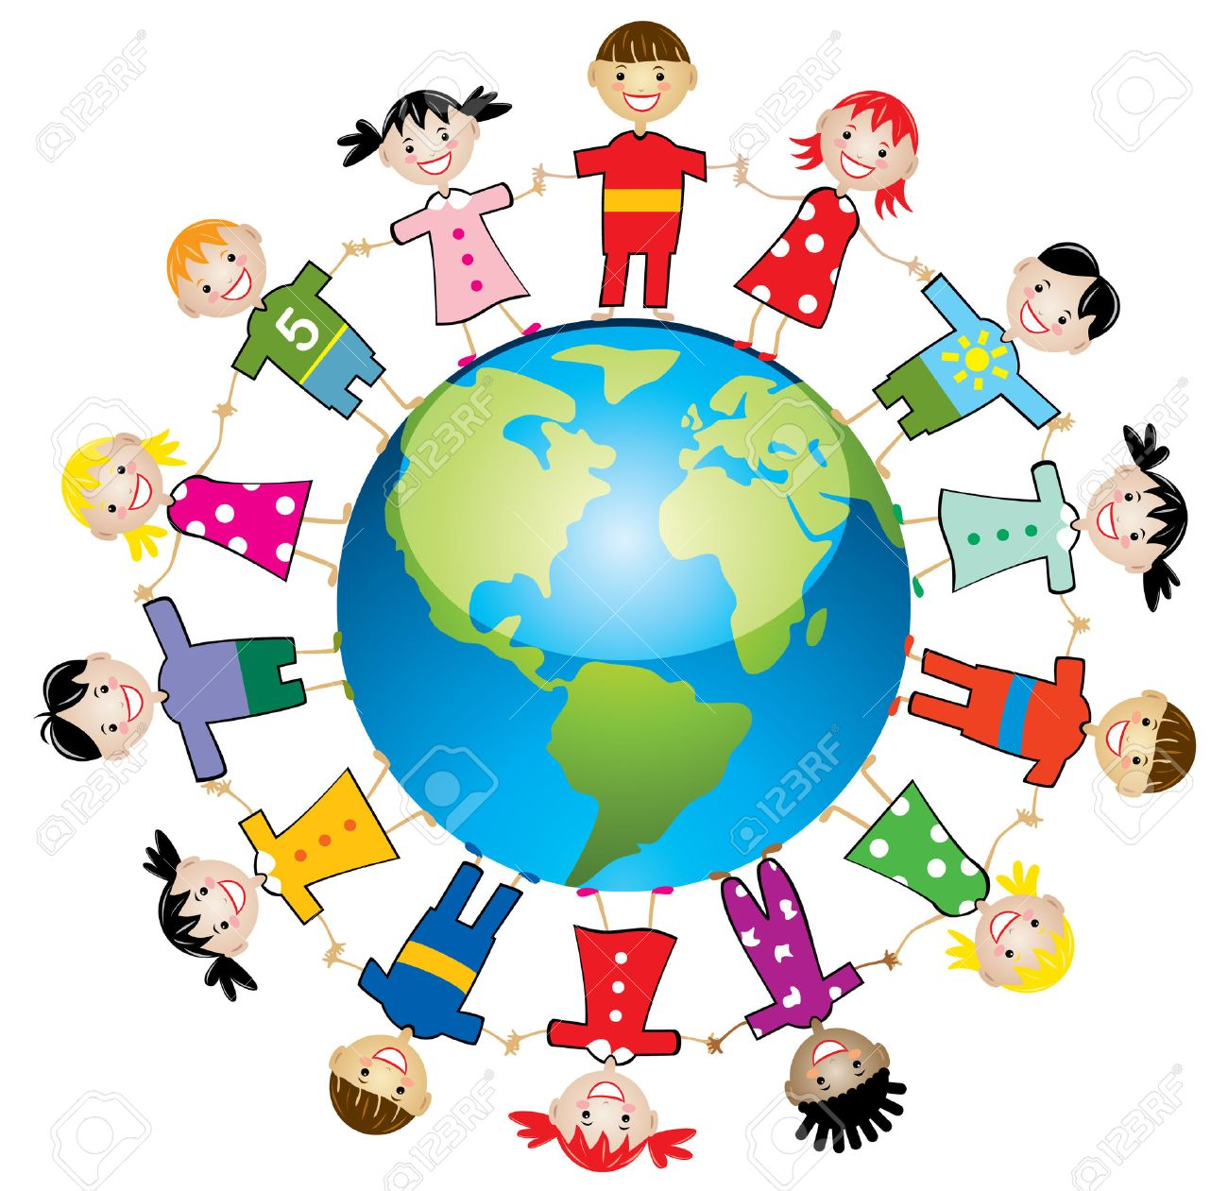
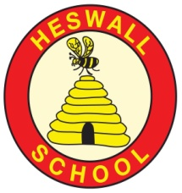
Hook: Play rumaal chor (indian game) and Koori oni (Japanese game) and the british variations of these games (duck, duck goose and stuck in the mud).

As a class we will place photographs of the children from our key text onto a map which shows the country and continent of where they live and this will stay on the class display.
Be able to perform ‘The Continent song’ which names the 7 continents
Choose a child from the book and label the picture with their name and country. Annotate with labels or speech bubbles.
Create an accurate self portrait
Create their own book about themselves

Connections
What are the connections to our curriculum past and present?

Is life the same for children
everywhere?
GOAL 6: Clean Water and Sanitation
GG15: Life on land

GLOBAL GOAL 16: Peace and Justice Strong Institutions

Key Vocabulary:
Continents, countries, same, different, compare, world, generations, culture, tradition, similarities, differences, experiences, skin tone

Reservoir

Pure

Water cycle

Water vapour

Basin

Body of water

Brook

Canal

Condensation

Evaporation

Depth

Texts: This is how we do it (Matt Lamothe)
Curriculum
What will we learn?
Children will:
Know there are 7 continents
Within those continents there are countries
Explain about different foods and different school and home life and how these experiences may be similar or different to their own experiences
Know how to draw a self portrait
Know how to write an information book (y2) or speech bubbles and labels (y1)

Community
What links can we develop‘Near and Far’?

Consider their own daily life and learn how their experiences have both similarities and differences to other children around the world

Link to Uganda water harvesting project

Compassion
What feelings to we wish to evoke?

Understand that children have different experiences from across the world. Even though people may eat different food, have different families and attend very different schools we still all share some things the same.

Children may have knowledge of our twin school and have some knowledge of the children who live there
The Y2 children have experience of the world from their ‘explorers’ topic including the continents and oceans (however we are aware that due to school closure not all children may have this knowledge - we will repeat this in this topic)
Covid 19 Gap file will be used to support planning and assessment

Creativity:
How will we show we understand in multiple ways? What does the Rainbow Continuum (Blooms Taxonomy) guide us to do?
Areas of learning (theme/subject)
Which subject areas will be included through this project? Literacy, Geography, Art, PHSCE, music
Significant individuals
Mr Herod, Denis Agaba(GAFI Uganda)

Resources
Photographs, maps, globe, computers, skin tone coloured pencils,

