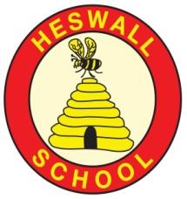
Is life the same for children
everywhere?
GOAL 6: Clean Water and Sanitation
GG15: Life on land

GLOBAL GOAL 16: Peace and Justice Strong Institutions

Resources
Photographs, maps, globe, computers, skin tone coloured pencils,
Areas of learning (theme/subject)
Which subject areas will be included through this project? Literacy, Geography, Art, PHSCE, music
Overall outcome
​Circle time – can the children share one similarity and one difference with a child from our key text.
​
Y1: Autumn 1: Medium Term Plan
Curriculum areas that will be covered in stand-alone units during this topic:
Science
Maths
RE
PE
Phonics
ICT
Music
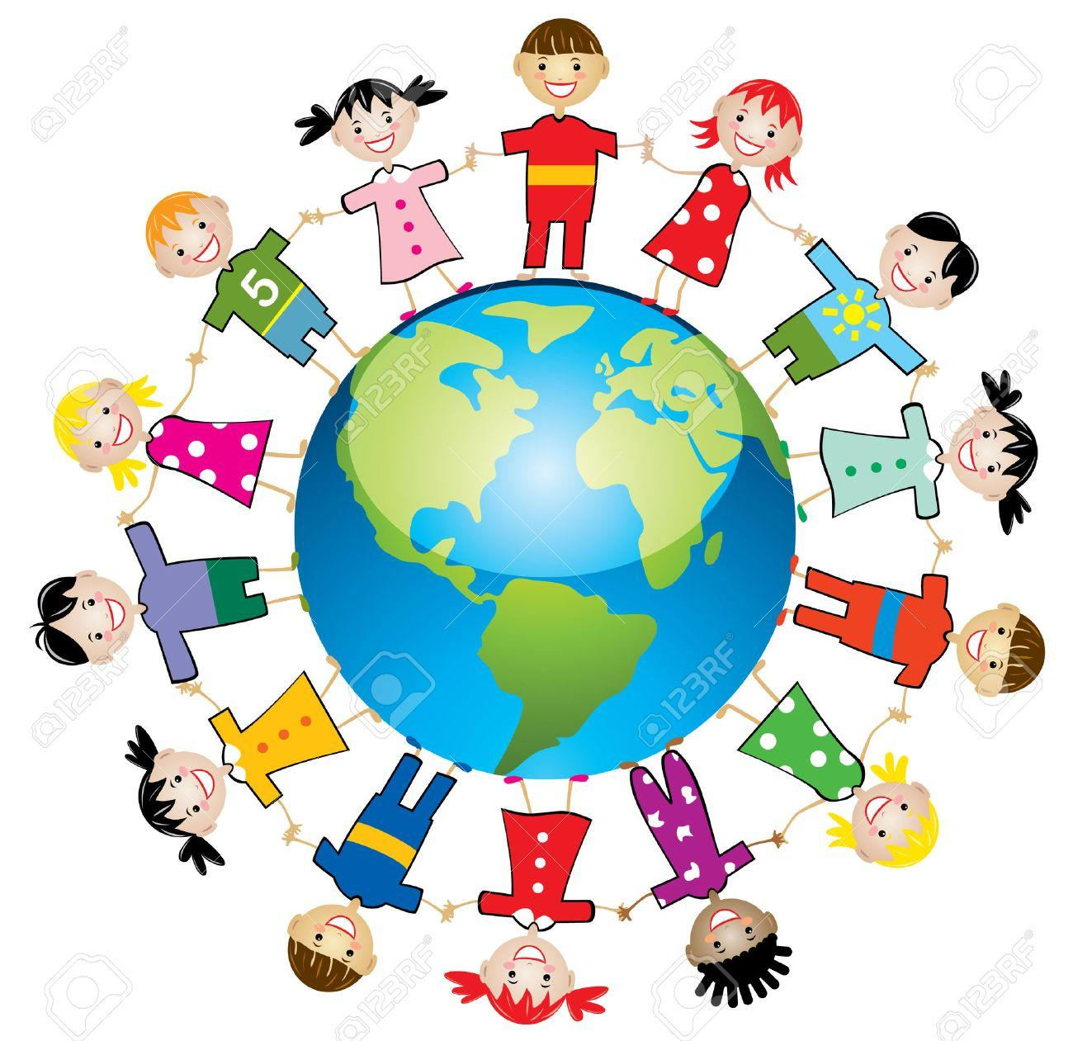
- The names of the 7 continents

- That continents are made up of land and not water

- About different foods, different school and home life and how these experiences may be similar or different to their own experiences

- How to draw a self portrait

- How to write an information book where each page is about a different aspect of their lives, using simple sentences, speech bubbles and labels to communicate meaning.

Texts: This is how we do it (Matt Lamothe)
Key Vocabulary:
Continents, countries, same, different, compare, world, tradition, similarities, differences, experiences, skin tone

Reservoir

Pure

Water cycle

Water vapour

Basin

Body of water

Brook

Canal

Condensation

Evaporation

Depth

Hook: Play Rumaal Chor (Indian game) and Koori Oni (Japanese game) and the British variations of these games (Duck, Duck, Goose and stuck in the mud).
Curriculum
What will we learn?
Creativity:
How will we show we understand in multiple ways? What does the Rainbow Continuum (Blooms Taxonomy) guide us to do?
Connections
What are the connections to our curriculum past and present?

Compassion
What feelings to we wish to evoke?
As a class we will place photographs of the children from our key text onto a map which shows the country and continent of where they live and this will stay on the class display.

Be able to perform ‘The Continents song’ which names the 7 continents

Choose a child from the book and label the picture with their name and country. Annotate with labels or speech bubbles.

Create an accurate self portrait

Create their own book about themselves

Children may have knowledge of our twin school and have some knowledge of the children who live there

Understand that children have different experiences from across the world. Even though people may eat different food, have different families and attend very different schools we still all share some things the same.

Significant individuals
Mr Herod, Mrs Bolton, Denis Agaba (GAFI, Uganda)

Community
What links can we develop ‘Near and Far’?

Consider their own daily life and learn how their experiences have both similarities and differences to other children around the world

Link to water harvesting project in Uganda

