Y1 : Autumn 1& 2: Medium Term Plan
Overall outcome
​Packages sent to our twin school in Uganda, consisting of letters and bunting, a Christmas stocking with a small gift and class books to share stories which the children have written.
​
Curriculum areas that will be covered in stand-alone units during this topic:
Science
Maths
RE
PE
Phonics
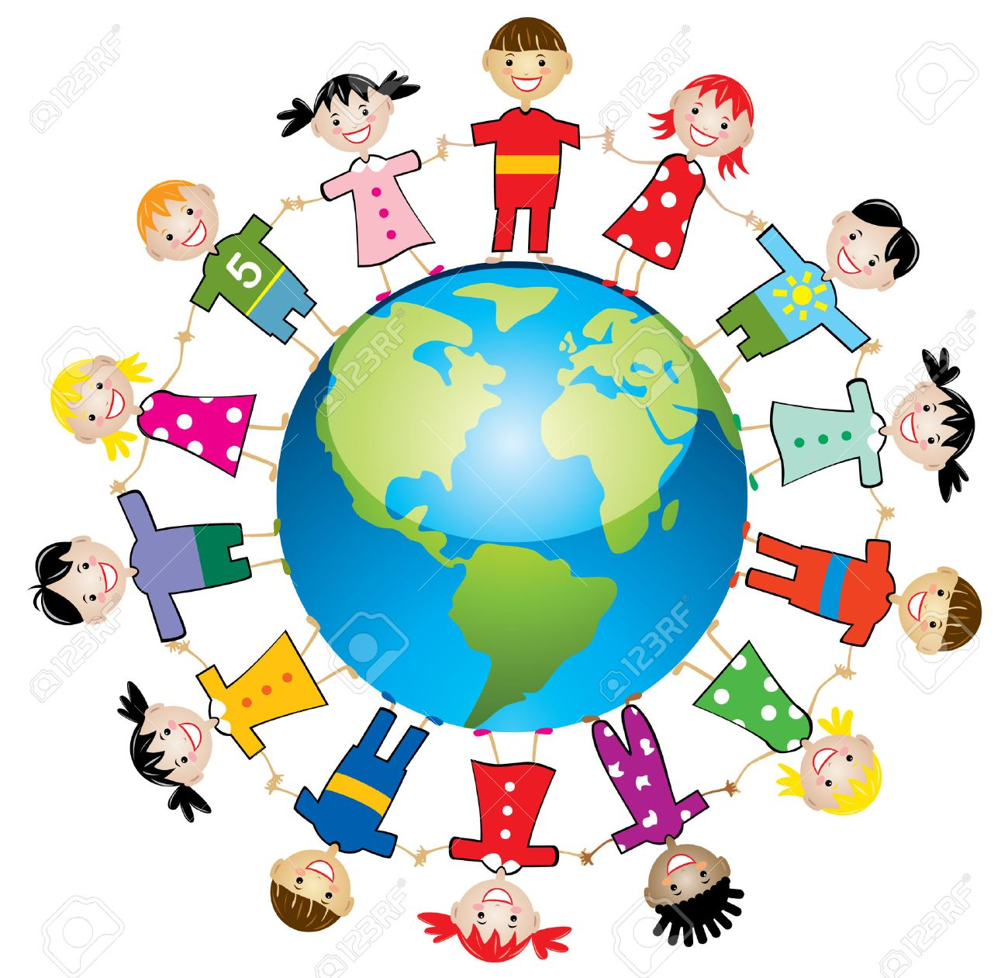
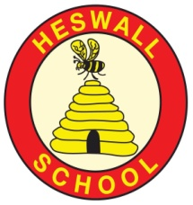

- Use ICT skills to create information pages about life in Uganda
- Design and make Christmas stockings to send as gifts to the children in our twin school to share one of our Christmas traditions
- Learn and perform some simple African songs and drumming patterns
- Create a piece of TingaTinga style art
Connections
What are the connections to our curriculum past and present?

Is life the same for children
everywhere?
GOAL 6: Clean Water and Sanitation

GLOBAL GOAL 16: Peace and Justice Strong Institutions

Key Vocabulary:
Uganda, England, Heswall, Kisoro, rainforest, village, town, lake, mountain, water harvester, volcanoes, TingaTinga, similar, different, poverty, drought, tradition, crane, fundraise.

Reservoir

Pure

Water cycle

Water vapour

Basin

Body of water

Brook

Canal

Condensation

Evaporation

Depth

Texts: Why the African Crane has a crown.
Hook:Photographs of Uganda washed up, in the style of Flotsam.
Curriculum
What will we learn?
Children will be able to:
- Recognise that life in Uganda can be both similar and different to life in England
- Locate England and Uganda on both a map of the world and a globe
- Locate Heswall in England and Kisoro in Uganda
- Explain the physical features of Uganda
- Explain what the flag of Uganda looks like, and explain why there is a crane on the flag
- Retell a traditional Ugandan story and innovate their own version

Community
What links can we develop‘Near and Far’?
- Discuss how our harvest festival will help those near to us, but through fundraising we are able to help those far away too
- Sending packages to Uganda
- Involving members of our community who have real life, expert knowledge and asking them to share this with our children
- Share stories with other classes

Compassion
What feelings to we wish to evoke?
Understand and empathise that life for all children is different due to the effects of poverty, drought, lack of clean water.

To feel as though they can make a difference to the lives of other people both near and far

To understand that happiness comes from within and is not materialistic

- Previous assemblies delivered by DRIP Uganda and Mrs Bolton
- River of pennies to raise money for water harvesters
- Build further links to school twinning programme
- Link our Harvest festival to fundraising for Uganda

Creativity:
How will we show we understand in multiple ways? What does the Rainbow Continuum (Blooms Taxonomy) guide us to do?
Areas of learning (theme/subject)
Which subject areas will be included through this project? Literacy, Geography, Music, Art, DT, PHSCE, Computing
Significant individuals
Mr Herod, Edward TingaTinga, Nicola Bolton

Resources
Photographs, maps, globe, paint, paintbrushes, powerpoint showing TingaTinga art, computers, felt, fabric pens, needles, thread, glue, scissors, pencils.

