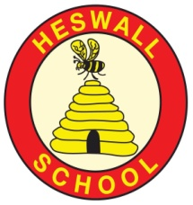
Overall outcome
Preparation of an assembly for Remembrance service.
​
​
Areas of learning (theme/subject)
Literacy, History, Geography, Science
PE, Music, Art, DT, PHSCE
Year 5: Medium Term Plan: Autumn
NB: This topic will be taught during Autumn Term in two sections, interspersed with a two week environmental topic during COP26 in November. Part 1: The Homefront/ Part 2: Life for a German child/The Holocaust
NB

Curriculum areas that will be covered in stand-alone units during this topic:

Science: Materials (some links to
designing Blackout Blinds)
RE : Islam

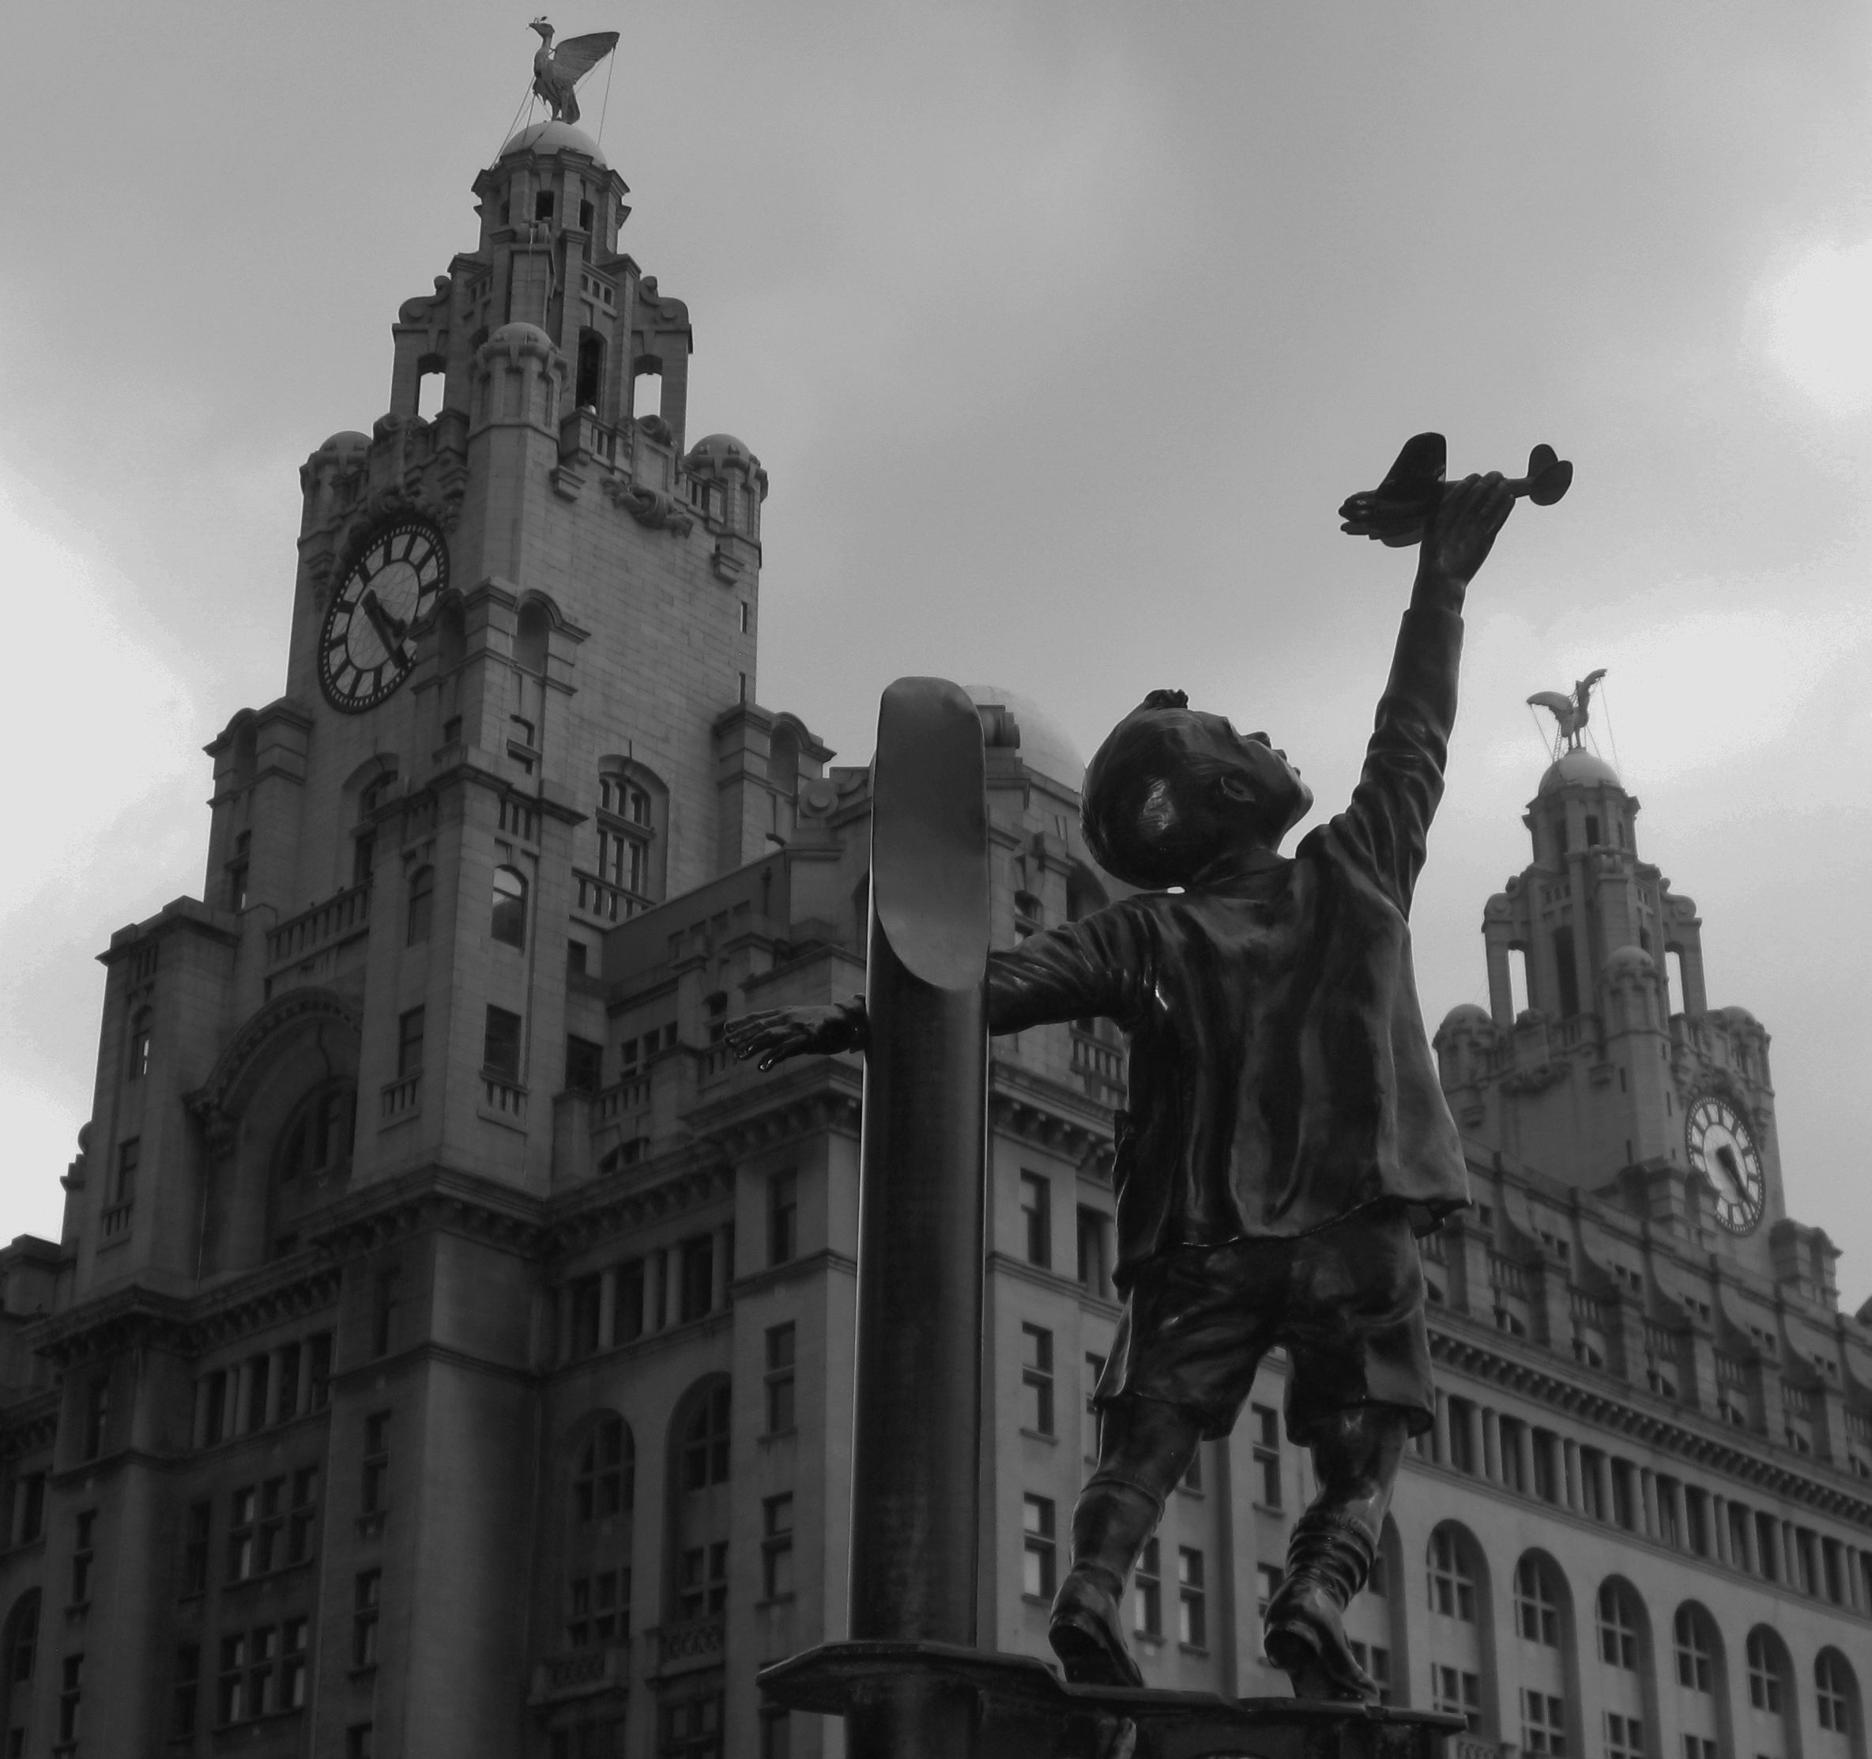
- Local recordings/ BBC broadcasts of people who survived the Blitz and were evacuated from Liverpool.

- Local historical materials

- Visit to Western Approaches and the bombed sites of Liverpool.

- Visit from local historians to share WW2 artefacts from Heswall

- Outdoor learning: Dig for victory/Rationing cooking

- Visit to Heswall Methodist Church for ‘The Hope Journey’, a morning of remembrance activities.

- Recordings / BBC broadcasts of people who survived the Holocaust/ lived in Berlin during the bombing by the Allies

Community
What links can we develop ‘Near and Far’?
- Understanding of the life of an evacuee- Experience a day as an evacuee.

- Understanding the effect of rationing on day to day lives.

- Understanding of the impact of war, through immersion in real life recounts and film footage.

- Realisation why wars occur, the lessons we can learn from it and recognition that some wars are happening today in other countries around the world. Link to refugees- Afghanistan.

- Empathy for victims of the Holocaust and understanding that sadly, the Holocaust is not the only genocide that has happened in history. eg Cambodia, Rwanda, Bosnia and Darfur

Compassion
What feelings to we wish to evoke?
Connections
What are the connections to our curriculum past and present?

Connections to previous learning
Annual commemoration of Remembrance Sunday during assembly.

Creativity:
How will we show we understand in multiple ways? What does the Rainbow Continuum (Blooms Taxonomy) guide us to do?
- Create Blitz pictures in the style of Lowry, to demonstrate understanding and emotion in response to research.
- Research and design and build an Anderson shelter for a family from the Wirral.
- Write diary entries to reflect understanding of key events including; evacuation and the Blitz.
- Drawing on knowledge of the Homefront, write and publish a flashback narrative to describe an event during the Blitz.
- Learn war time songs and cook with wartime rations.
- Drawing on knowledge of WW2, use media to design a propaganda poster to demonstrate knowledge of an aspect of WW2.
- Create blackout poetry to reflect understanding of key WW2 events including; the holocaust.
- Drawing on research, write and take part in balanced argument to compare and contrast life as a UK and German child WW2.

Curriculum
What will we learn?
Children will be able to:

- Explain why WW2 war started and the countries involved.
- Recognise the impact of war on the community of Heswall and Merseyside.
- Recall key dates and explain their significance
- Recall key facts about rationing and evacuation
- Explain how and why the changing role of women was significant to the war effort
- Understand the meaning of propaganda and how it can be used rightly or wrongly to change public perception.
- Explain what everyday life was like for a child living in Germany during WW2 and compare and contrast this with life in the UK.
- Recognise how WW2 has influenced life in the UK and the world today and the moral and practical lessons we can learn from it with a focus on the Holocaust.
- Re

Resources
WW2 Artefacts
Living history recounts and film footage

Vehicle Texts: Friend or Foe, Rose Blanche, Diary of Anne Frank, war song lyrics, poetry from Local Recounts of evacuation/Blitz, Recounts of holocaust/life in Germany during the war.

Key Vocabulary: Homefront, Luftwaffe,, Blitz, evacuation, ARP Wardens, blackout, axis powers, allied powers, rationing, air raid shelter, Anderson shelter, gas mask, air raid siren, bombing, munitions factory, telegram, Luftwaffe, evacuation, , axis powers, allied powers, rationing, bombing, Aryan, holocaust, victim, propaganda, genocide, political, Jews, persecuted, racist, compare, contrast.

Reservoir

Pure

Water cycle

Water vapour

Basin

Body of water

Brook

Canal

Condensation

Evaporation

Depth

Hook: Exploration of artefacts ‘buried in the field’- in an evacuee suitcase discovered with a metal detector.
What is the impact of war?
GLOBAL GOAL 16: Peace and Justice Strong Institutions

Significant individuals
Adolf Hitler, Winston Churchill, Lowry, Vera Lynn, teacher and children’s relatives, Anne Frank, Corrie Ten Boon, Rose Blanche

Recounts from local residents

