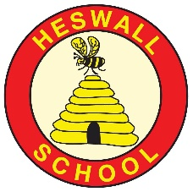
HESWALL PRIMARY SCHOOL RISK ASSESSMENT: Opening School 28.2.22
Location: Heswall Primary School (HPS) | Date assessment  Undertaken 4.4.22 | Assessment undertaken by: Jon Lawrenson (HT), Michelle Spofforth (SBM) and Nicky Bolton (DHT)
Activity or situation:  Living with Covid 19 | Review  date: Weekly review | Signatures:

From 1 April, the government's guidance on living with COVID-19 replaces the DfE's operational guidance for schools.
Legislation and guidance
Health and Safety at Work Act etc. 1974
Management of H&S at Work Regulations 1999
Workplace (Health, Safety and Welfare) Regulations 1992
N.B. All risk assessments referred to within this document have been revised and are available on website www.jeannefairbrotherassociates.com

1) Hazard / Activity | 2) Who can be harmed and how? | 3) What controls exist to reduce the risk?  Have you followed the hierarchy of controls (eliminate, substitute etc)? | Risk Score  Consequence  X Likelihood | 4) Any further action.  This should be included in the action plan (5), below
Failing to have adequate outbreak management/contingency plans to allow for stepping measures up and down. | Staff, pupils, visitors, contractors increased risk of transmission of COVID 19 | - HPS has a Coronavirus (COVID-19) Contingency Plan risk assessment (also known as an outbreak management plan) if restrictions need to be implemented due to COVID 19 variants outbreak.  - HPS will only:  - Consider attendance restrictions as a last resort  - Keep measures to the minimum number of groups possible  - Keep measures for the shortest amount of time possible  - HPS will take additional steps to manage the transmission of COVID-19 and seek public health advice if the number of positive cases reaches a certain threshold.  - HPS will follow measures recommended by the Local Authority, Director of Public Health and local protection teams (HPTs) as part of the outbreak management responsibilities.  - Wirral schools contact Wirral LA Covid helpline 0151 666 3600 Email: covidschoolsupport@wirral.gov.uk  - HPS has updated its School Emergency Plan in line with April 1st DfE guidance : Emergency planning and response for education, childcare, and children’s social care settings which includes public health emergencies .  - School will refer to UK Health Security Agency (UKHSA) health protection in education and childcare settings  - Remote education plans are in place for pupils who are self-isolating or shielding. Staff to continue to use Google Classrooms to provide a broad and balanced curriculum to any child self isolating . | 3X2=6
Face coverings | Staff, pupils, visitors, contractors increased risk of transmission of COVID 19 | - Face coverings are no longer advised for pupils, staff and visitors in classrooms or communal areas.  - Staff and pupils should follow wider advice on face coverings outside of school, including on transport to and from school.  - HPS may be advised by a director of public health that face coverings should temporarily be worn in communal areas or classrooms (by pupils, staff and visitors, unless exempt). HPS has contingency plans that cover this possibility.  - Any staff who wish to wear a face covering in school will be supported to do so. | 3X2=6
School fails to ensure good hygiene & cleaning standards in school to reduce risk of transmission. | Staff, pupils, visitors, contractors increased risk of transmission of COVID 19 | Hand hygiene -  - HPS will continue to ensure that staff & pupils maintain high standards of hand hygiene.  - Suitable facilities are provided for individuals to wash/sanitise their hands regularly  - Pupils are supervised, where appropriate, to use hand sanitizer safely.  Respiratory hygiene  - School emphasises the ‘catch it, bin it, kill it’ approach with bins & tissues available.  Cleaning  - HPS will maintain appropriate cleaning regimes, using standard products such as detergents with a focus on frequently touched areas.  - Appropriate cleaning schedules are in place and include regular cleaning of areas and equipment. A daily clean of frequently touched surfaces will continue prior to lunchtime. | 3X2=6
Events in school | Staff, pupils, visitors, contractors increased risk of transmission of COVID 19 | - School will plan and complete a separate risk assessment for any events held in school and has carefully following the latest DfE/PHE guidance  - School will consult Local Authority COVID helpline for specific advice if required on holding events | 3X2=6
Ventilation - failure to ensure all occupied spaces are well ventilated. | Staff, pupils, visitors, contractors increased risk of transmission of COVID 19 | - When school is in operation, it is well ventilated with comfortable teaching environments.  - Poorly ventilated spaces have been identified  - When holding events where visitors are on site e.g. school plays, ventilation is increased.  - Mechanical ventilation is adjusted to increase the ventilation rate wherever possible and checked to confirm that normal operation meets current guidance and that only fresh outside air is circulated.  - Systems should be adjusted to full fresh air or, if this is not possible, then systems should be operated as normal as long as they are within a single room and supplemented by an outdoor air supply.  - All mechanical ventilation systems are maintained in accordance with the manufacturers’ recommendations.  - School opens external windows, doors & internal doors (if they are not fire doors and where safe to do so) to increase ventilation.  - During colder weather, the need for increased ventilation while maintaining a comfortable temperature is balanced; opening higher vents, arranging seating away from draughts.  - In cooler weather to reduce thermal discomfort caused by increased ventilation, pupils can wear additional, suitable indoor items of clothing in addition to their usual uniform  - Purging or airing rooms as frequently as possible to improve ventilation usually when the room is unoccupied.  - Outside space will be used, where practical.  - CO2 monitors are used to help identify where a space is poorly ventilated. HPS will take steps to improve ventilation if CO2 readings are consistently high. | 3X2=6
Close contacts | Staff, pupils, visitors, contractors increased risk of transmission of COVID 19 | - From 24 February, routine contact tracing will end. Contacts will no longer be required to self-isolate or advised to take daily tests.  - Local health teams continue to use contact tracing and provide context-specific advice where they assess this to be necessary as part of their role in managing infectious  diseases.  - Staff or pupils who are close contacts should:  - avoid contact with anyone who is at higher risk of becoming severely unwell if they are infected with COVID-19, especially those whose immune system means they are at higher risk of serious illness from COVID-19, despite vaccination  - limit close contact with other people especially in crowded, enclosed or poorly ventilated spaces  - wear a well-fitting face covering made with multiple layers or a surgical face mask if you do need to have close contact with other people, or you are in a crowded place  - wash hands frequently with soap and water or use hand sanitiser | 3X2=6 | JL to share RA with staff to ensure they are aware of guidelines.
Positive case unaware of new guidance | Staff, pupils, visitors, contractors increased risk of transmission of COVID 19 | - Those with a positive test result will be advised to try to stay at home and avoid contact with other people:  - Staff for 5 days  - Pupils for 3 days  - Both pupils and staff should try to stay home and avoid contact with others if they have symptoms of a respiratory infection and a high temperature or if they feel unwell (returning to school when they feel well enough, and no longer have a high temperature) | 3X2=6
Asymptomatic testing | Staff, pupils, visitors, contractors increased risk of transmission of COVID 19 | - Staff and students in all education and childcare settings are no longer required to carry out twice weekly asymptomatic testing.  - Free testing is no longer available for schools  - If there's an outbreak in school, local directors of public health might advise testing for staff, for a period of time  - Spare tests should be kept and only used if advised by your local health protection team, local authority or director of public health. | 3X2=6
People at higher risk of becoming seriously unwell from a respiratory infection, including COVID-19  - older people  - those who are pregnant  - those who are unvaccinated  - people of any age whose immune system means they are at higher risk of serious illness  - people of any age with certain long-term conditions | Staff, pupils, visitors, contractors increased risk of transmission of COVID 19 | - HPS is aware that certain staff and pupils may be at higher risk becoming seriously unwell from respiratory infections.  - People in this category are advised to follow Living safely with respiratory infections including Covid 19  - HPS will discuss any concerns with employees and parents/carers. And this may form the basis of a personal risk assessment.  - Employees who have received personal advice from their specialist or clinician on additional precautions to take should continue to follow that advice and advise school.

Risk Rating | Action Required
20 - 25 | Unacceptable – stop activity and make immediate improvements
10 - 16 | Urgent action – take immediate action and stop activity, if necessary, maintain existing controls vigorously
5 - 9 | Action – Improve within specific timescales
3 - 4 | Monitor – but look to improve at review or if there is a significant change
1 - 2 | Acceptable – no further action but ensure controls are maintained & reviewed

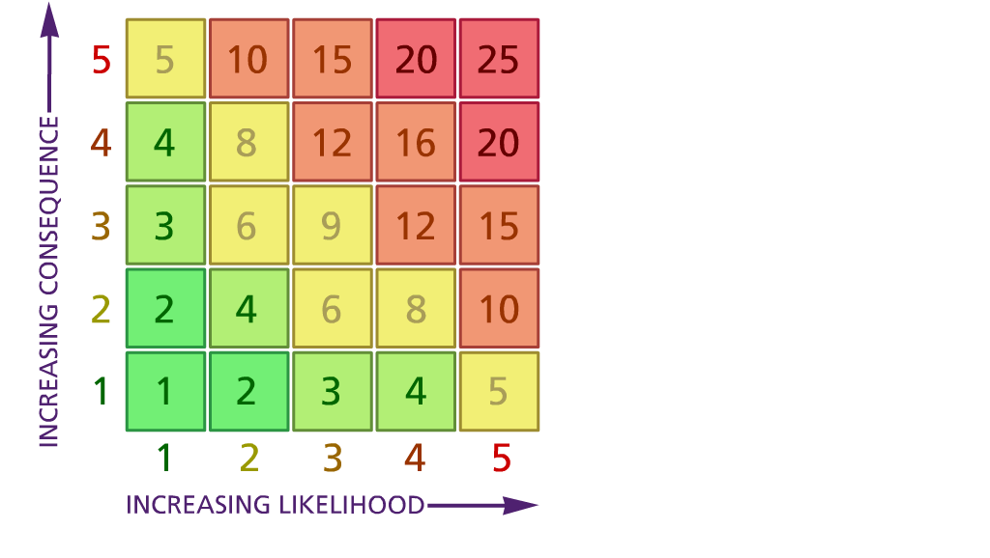

Likelihood: Consequence:

(1) List hazards something with the potential to cause harm here
(2) List groups of people who are especially at risk from the significant hazards which you have identified
- List existing controls here or note where the information may be found. Then try to quantify the level of risk the likelihood of harm arising that remains when the existing controls are in place based on the number of persons affected, how often they are exposed to the hazard and the severity of any consequence. Use this column to list the controls that you might take and develop all or some of that list into a workable action plan. Have regard for the level of risk, the cost of any action and the benefit you expect to gain. Agree the action plan with your team leader and make a note of it overleaf. If it is agreed that no further action is to be taken this too should be noted.
5 – Very likely 5 – Catastrophic

4 – Likely 4 – Major
3 – Fairly likely 3 – Moderate

2 – Unlikely 2 – Minor

1 – Very unlikely 1 – Insignificant

 | 5. Action plan | Responsible | Completed
1 | All staff to monitor controls in place and any concerns to be reported to JL and NB to assess and action as required. RA to be treated as a live document. JL and NB to meet monthly to discuss actions taken. | NB and JL and all staff
2 | RA shared with LA, Unions, staff, govs, parents and wider school. | NB and JL
3 | JL to check risk assessments for events to ensure contingency plans are in place. | JL
4 | Parents and staff to be regularly informed of the current status of measures in school. JL to include coronavirus guidance in regular newsletter | JL
 | Action plan agreed by (NAME & DATE)

