Y6 Medium Term Plan
Overall outcome
​Sharing of knowledge gained with local historians.
​
Curriculum areas that will be covered in stand-alone units during this topic:

Science: Humans including other animals
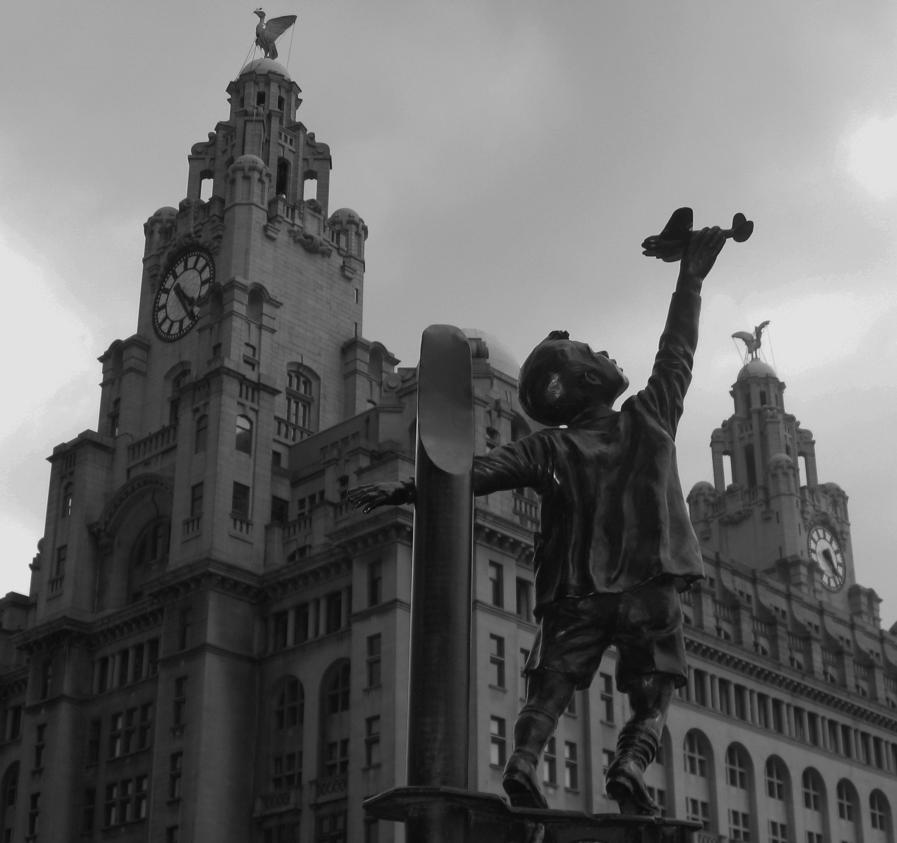
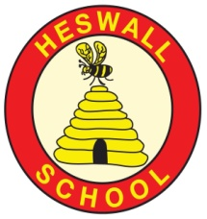
Creativity:
How will we show we understand in multiple ways? What does the Rainbow Continuum (Blooms Taxonomy) guide us to do?
- Create Blitz pictures to demonstrate understanding and emotion in response to research.
- Research and design and build an Anderson shelter for a family from the Wirral.
- Write diary entries to reflect understanding of key events including; evacuation and the Blitz.
- Drawing on knowledge of the Homefront, write and publish a flashback story to describe an event during the Blitz.
- Learn war time songs and cook with wartime rations.
- Write passages, in role, to reflect understanding of effects of the Holocaust in WW
- Design propaganda posters in the style of those seen in WW2.

Year 6: What is the impact of war?
GLOBAL GOAL 16: Peace and Justice Strong Institutions

Significant individuals
Adolf Hitler, Winston Churchill, Mrs Courtenay’s relatives & children’s relatives,

Recounts from local residents
Texts: Carrie’s War, Friend or Foe, War song lyrics, Recounts of evacuation/Blitz, Rose Blanche, Recounts of holocaust/life in Germany during the war
Key Vocabulary:Homefront, Luftwaffe, Blitz, evacuation, ARP Wardens, blackout, axis powers, allied powers, rationing, air raid shelter, Anderson shelter, gas mask, air raid siren, bombing, munitions factory, telegram, Luftwaffe, evacuation, , axis powers, allied powers, rationing, bombing, Ayran, holocaust, victim, propaganda, genocide, political, Jews, persecuted, racist, compare, contrast, industry

Reservoir

Pure

Water cycle

Water vapour

Basin

Body of water

Brook

Canal

Condensation

Evaporation

Depth

Hook:Exploration of artefacts ‘buried in the field’- in an evacuee suitcase, Suitcase belonging to Rose Blanche
Curriculum
What will we learn?
Children will be able to:
- Explain why WW2 war started and the countries involved.
- Recognise the impact of war on the community of Heswall and Merseyside.
- Recall key dates and explain their significance
- Recall key facts about rationing and evacuation
- Explain how and why the changing role of women was significant to the war effort
- Explain what everyday life was like for a child living in Germany during WW2 and compare and contrast this with life in the UK.
- Understand the meaning of propaganda and how it can be used rightly or wrongly to change public perception.
- Explain how the events of WW2, in particular the Holocaust, influenced society today and the moral and practical lessons we can learn from it.

Community
What links can we develop‘Near and Far’?
- Local recordings/ BBC broadcasts of people who survived the Blitz and were evacuated from Liverpool.

- Local historical materials

- Recordings / BBC broadcasts of people who survived the Holocaust/ lived in Berlin during the bombing by the Allies
- Visit to Birkenhead school tunnels

- Rationing cooking with Fun Food Chef

- Visit by Local WW2 veterans

Compassion
What feelings to we wish to evoke?
- Understanding of the life of a child in the war-Experience hiding in the tunnels
- Understanding the effect of rationing on day to day lives.
- Understanding of the impact of war, through immersion in reallife recounts and film footage.
- Realisation why wars occur, the lessons we can learn from it and recognition that some wars are happening today in other countries around the world.
- Understanding of the impact of war on the families governed by Axis powers, through immersion in real life recounts and film footage.
- Empathy for victims of the Holocaust and understanding that sadly, the Holocaust is not the only genocide that has happened in history. eg Rwanda

Connections to previous learning
Annual commemoration of Remembrance Sunday during assembly.

Connections to Future learning
Sessions with Reverend on Holocaust Day
Connections
What are the connections to our curriculum past and present?

Areas of learning (theme/subject)
Literacy, History, Geography,
PE, Music, Art, DT, PHSCE
Resources
WW2 Artefacts
Living history recounts and film footage

