**Year 1 : Autumn 1 & 2: Medium Term Plan**

Overall outcome

​Packages sent to our twin school in Uganda, consisting of letters and bunting, a Christmas stocking with a small gift and class books to share stories which the children have written.

​

|  |
| --- |
| **Curriculum areas that will be covered in stand-alone units during this topic:**  **Science**  **Maths**  **RE**  **PE**  **Phonics** |

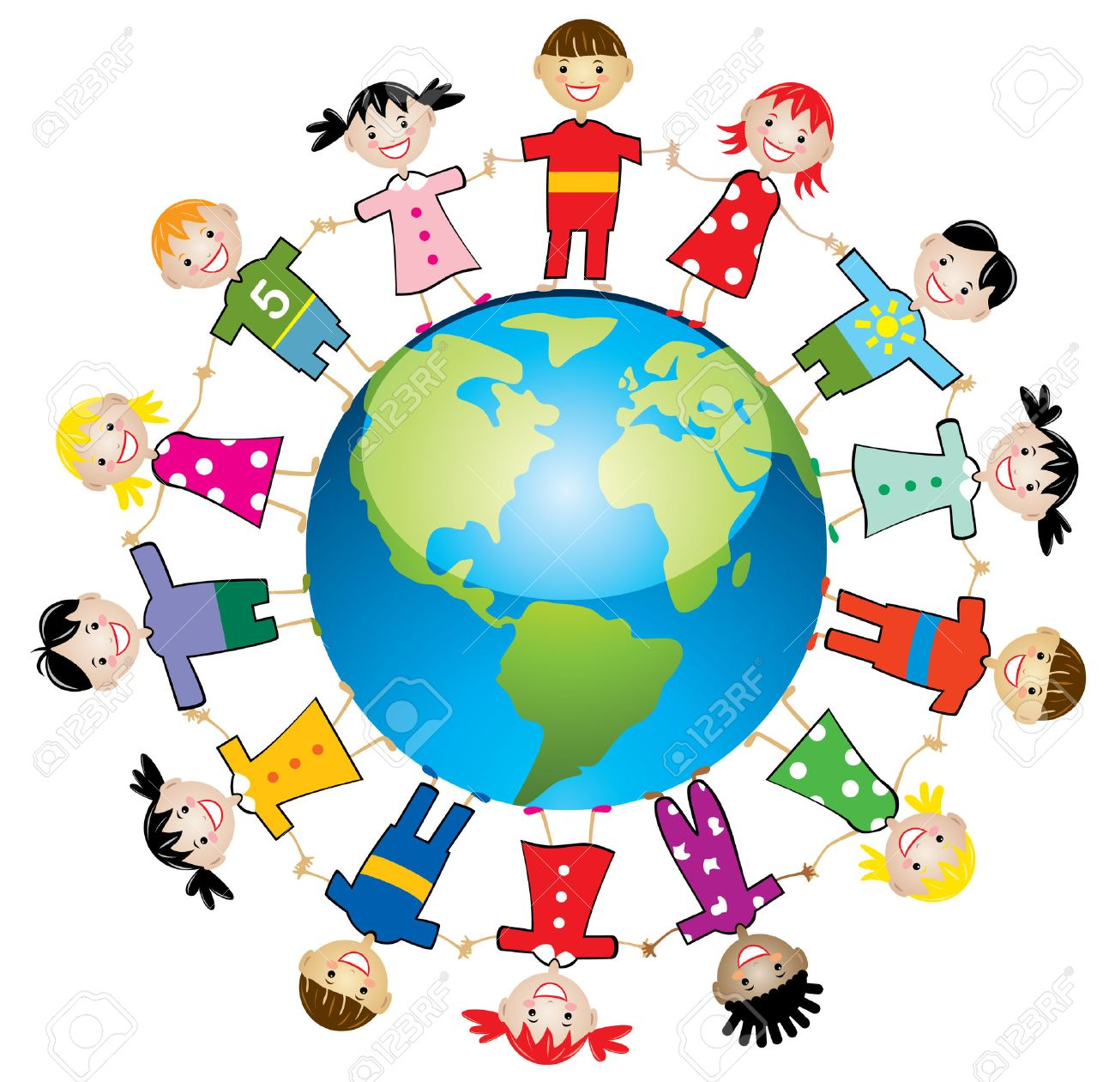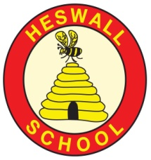

* Use ICT skills to create information pages about life in Uganda
* Design and make Christmas stockings to send as gifts to the children in our twin school to share one of our Christmas traditions
* Learn and perform some simple African songs and drumming patterns
* Create a piece of TingaTinga style art

Connections

*What are the connections to our curriculum past and present?*

*Is life the same for children*

*everywhere?*

[GOAL 6: Clean Water and Sanitation](http://www.un.org/development/desa/disabilities/envision2030-goal6.html)

**GLOBAL** [**GOAL 16: Peace and Justice Strong Institutions**](http://www.un.org/development/desa/disabilities/envision2030-goal16.html)

**Key Vocabulary:**

**Uganda, England, Heswall, Kisoro, rainforest, village, town, lake, mountain, water harvester, volcanoes, TingaTinga, similar, different, poverty, drought, tradition, crane, fundraise.**

Reservoir

Pure

Water cycle

Water vapour

Basin

Body of water

Brook

Canal

Condensation

Evaporation

Depth

**Texts: Why the African Crane has a crown.**

**Hook:**Photographs of Uganda washed up, in the style of Flotsam.

**Curriculum**

*What will we learn?*

Children will be able to:

* Recognise that life in Uganda can be both similar and different to life in England
* Locate England and Uganda on both a map of the world and a globe
* Locate Heswall in England and Kisoro in Uganda
* Explain the physical features of Uganda
* Explain what the flag of Uganda looks like, and explain why there is a crane on the flag
* Retell a traditional Ugandan story and innovate their own version

Community

*What links can we develop‘Near and Far’?*

* Discuss how our harvest festival will help those near to us, but through fundraising we are able to help those far away too
* Sending packages to Uganda
* Involving members of our community who have real life, expert knowledge and asking them to share this with our children
* Share stories with other classes

Compassion

*What feelings to we wish to evoke?*

Understand and empathise that life for all children is different due to the effects of poverty, drought, lack of clean water.

To feel as though they can make a difference to the lives of other people both near and far

To understand that happiness comes from within and is not materialistic

* Previous assemblies delivered by DRIP Uganda and Mrs Bolton
* River of pennies to raise money for water harvesters
* Build further links to school twinning programme
* Link our Harvest festival to fundraising for Uganda

Creativity:

*How will we show we understand in multiple ways? What does the Rainbow Continuum (Blooms Taxonomy) guide us to do?*

**Areas of learning (theme/subject)**

Which subject areas will be included through this project? Literacy, Geography, Music, Art, DT, PHSCE, Computing

**Significant individuals**

**Mr Herod, Edward TingaTinga, Nicola Bolton**

**Resources**

**Photographs, maps, globe, paint, paintbrushes, powerpoint showing TingaTinga art, computers, felt, fabric pens, needles, thread, glue, scissors, pencils.**