31 March 2017
Dear Parents

eSchools App- Please Download
A reminder for parents to please download the eSchools app and type in the user name and password that was provided for parents’ evening. We can utilise our school website to send you text messages to phones for important messages at no cost to the school. We have to pay for every text we send to a phone that doesn’t have the app.

Charity Collections
You have been incredibly generous this term for those less fortunate than we are. You raised £148.50 for Comic Relief; £341.55 [+ proceeds from the Bake Sale] to send Chloe to the USA for life-saving treatment; and £555.64 for the Bennet family of Irby who write, “We want to thank you for your very generous fundraising activities after the loss of our parents. Your kindness will help us continue our interests in the performing arts, as mum and dad wanted us to do. We expect some of you may have lost people you love too and we really appreciate you thinking of us and helping us in this way. With best wishes, Luke, Hannah and Oliver Bennet.” Thank you for being so caring.

HSA
Thanks to the HSA for all their dedication and efforts with the recent school events. They provided the refreshments during the Key Stage 1 Mothers’ Day performance, put on an excellent Family Fun Night and this week have organised both the school disco and the Easter Bonnet competition. Don’t forget that the HSA have a Facebook page to keep you informed of all their events (Heswall Primary School HSA).

Parents’ Evening Feedback
The feedback from the online surveys that most of you completed during the recent parents’ evening has now been published on the school website. You will find it under the ‘Useful Information’ tab. Again, the results have been extremely positive and we will continue to push for future school improvement. Thank you to everybody who took the time to complete the surveys.

Meal Deals
Attached to this letter is the Meal Deals Menu for the Summer Term, which we hope you will enjoy. There is an opportunity to have a Grab Bag which they can take outside to eat if the weather is good.

Cash into School
Please be aware that when we return to school after Spring Break, we will not be able to accept the old £5 notes.

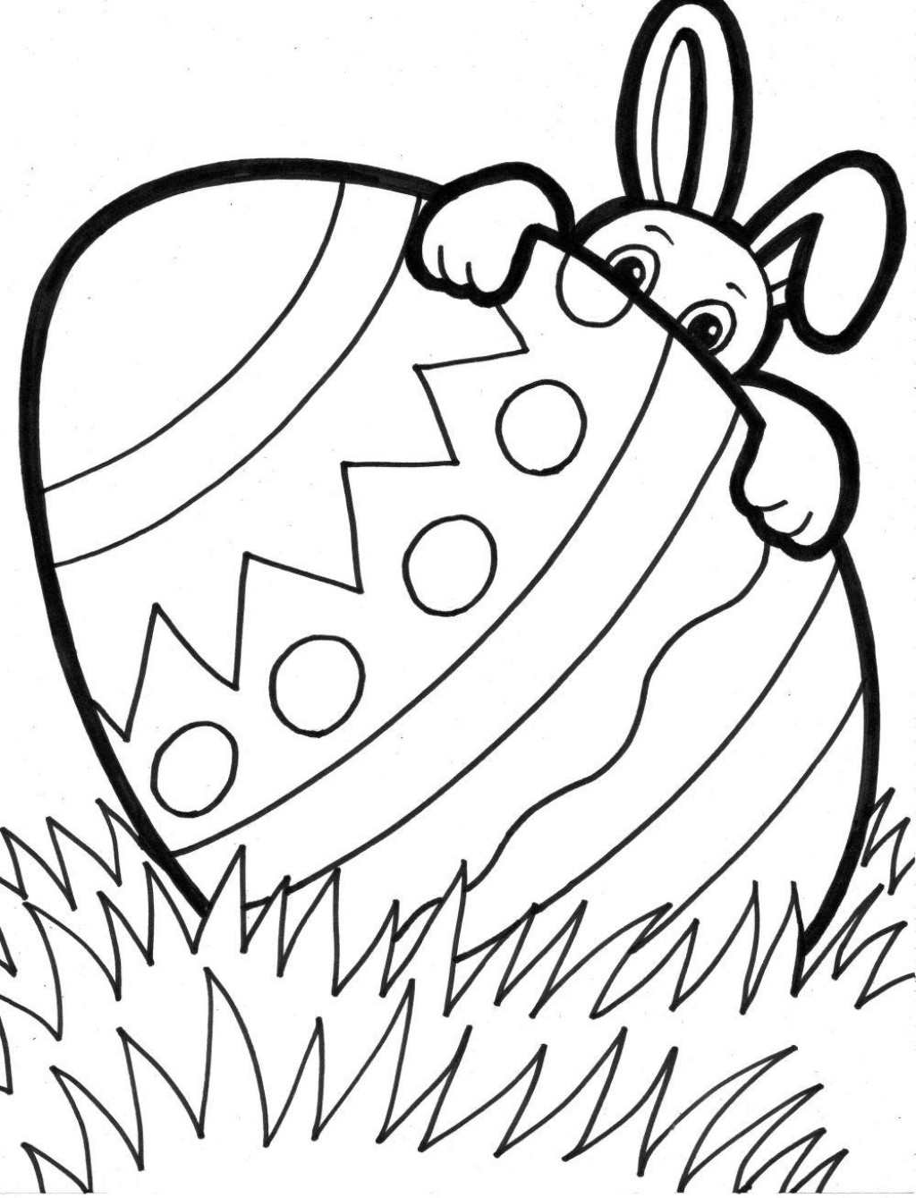
We hope you all have a wonderfully happy and health Spring Break. A reminder that the Easter weekend is at the end of Spring break this year, and this will be followed by an Inset Day on Tuesday 18 April. We look forward to seeing you all on Wednesday 19 April.

Yours sincerely

J Lawrenson
Headteacher

