Overall outcome
​Preparation for film- A Planet Full of Plastic

​
Year 6 :Medium Term Plan: Spring 1
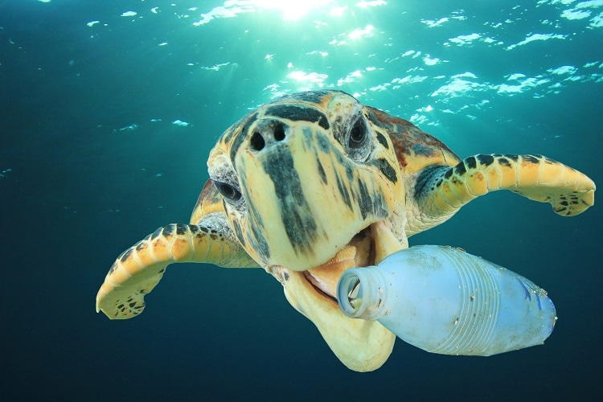
Curriculum areas that will be covered in stand-alone units during this topic:

Science: Evolution and Inheritance

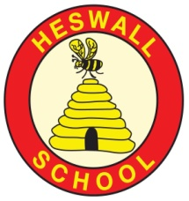
Curriculum
What will we learn?
Children will be able to:
- Investigate how plastic pollution affects climate change and the marine environment.
- Construct arguments to persuade people to make different lifestyle choices about single use plastics.
- Identify areas in the oceans of the world affected by plastic pollution.
- Develop a chronologically secure knowledge of events in the Stone Age
- Investigate different homes from the Palaeolithic, Mesolithic and Neolithic times
- Experience what people ate in the Stone Age and how their diet changed
- Recognise how excavations in Skara Brae have helped us to gain understanding of life in the Stone Age.
- Compare and contrast life in theStone Age with life today

Hook:
1) Exploration of Blue Planet footage
2) Stone Age immersion day
Year 6:What would life be like without plastic?
GLOBAL GOAL 14: Life below water
GLOBAL GOAL 13: Climate Action

Significant individuals
Sir David Attenborough – Plastics
Greta Thunberg- Plastics

Texts: A Planet Full of Plastic, A Street Through Time, Articles on climate change, articles on Skara Brae, Wolf Brother
Key Vocabulary: Plastic: recycled, biodegrade, debate, climate change, renewable energy Stone Age: excavation, Skara Brae, Palaeolithic, Mesolithic, Neolithic , artefact

Reservoir

Pure

Water cycle

Water vapour

Basin

Body of water

Brook

Canal

Condensation

Evaporation

Depth

Community
What links can we develop‘Near and Far’?
- Visit from Scottish Power to discuss renewable energy and how this impacts climate change.

- Sharing of WSUS film with school in Uganda

- Participation in WSUS 2020

Compassion
What feelings to we wish to evoke?
- Understanding that they can be agents of change; through letter writing and balanced discussons.
- Insight, through using varied viewpoints, into complexity of issues surrounding single use plastic.
- Realisation that to have opinions, you must thoroughly research your subject matter and be able to underpin your arguments with real facts.

Connections to previous learning
Plastic Pledge Market July 2019
Wirral Saves the Planet & Extinction is Forever Film
Development of whole school plastic Pledge/involvement in Wirral C2C
Link to Flotsam work in September 2019

Connections to Future learning
Preparation for Wirral Science Under the Stars project
Connections
What are the connections to our curriculum past and present?

Creativity:
How will we show we understand in multiple ways? What does the Rainbow Continuum (Blooms Taxonomy) guide us to do?
- Contribute to the creation of a film @A planet full of Plastic (and how we can help)
- Write a persuasive letter to encourage a local business to stop using single use plastics.
- Discuss, by developing a balanced argument, the pros and cons of single use plastics.
- Create cave paintings and Stone Age tools using natural resources.
- Design PPt’s to produce a tour guide for Skara Brae
Areas of learning (theme/subject)
Literacy, History, Geography, Science
PE, Music, Art, DT, PHSCE
Resources
Plastic pledge resources
Stone age artefacts/books

